Bug_01:
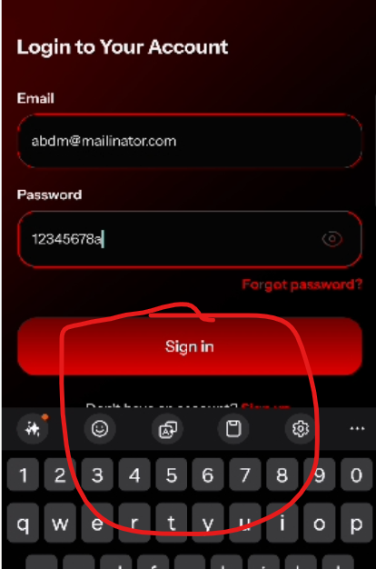
Sign Up button not visible when keypad is open
Bug_02:
When user login normally, then click on back button user redirected to Get Started page and have to login again.
Bug_03:
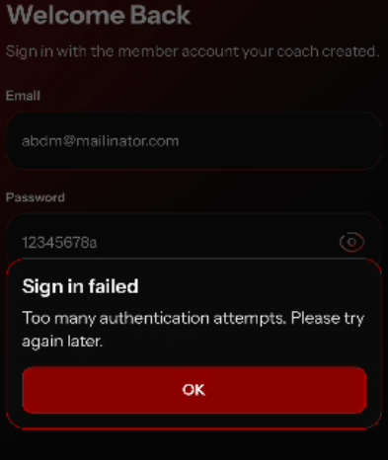
The error popup appers on coach app when users tries with invalid credentials again n again, then student tries to login at the same time from student app. The app shows the same error.

